Issues we observed during the exploration on Sandbox.

1.) What should be done if this error appears even after retrying?

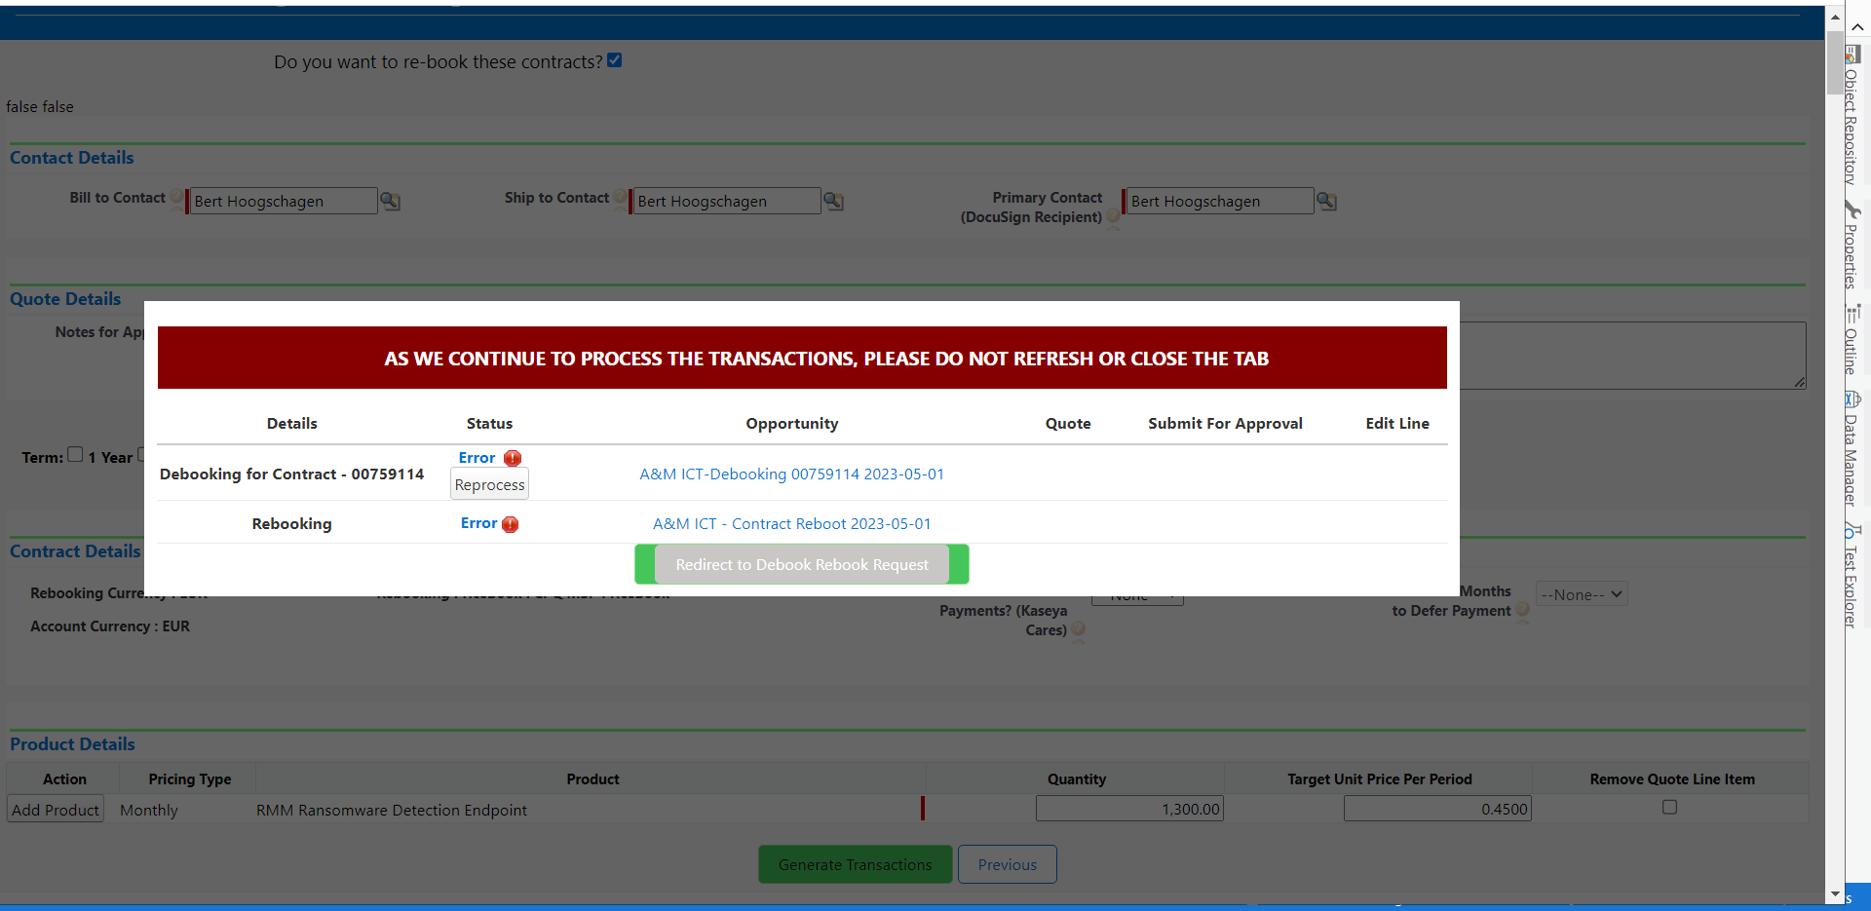

2.) This issue appeared after clicking initiate Contract Modification button?

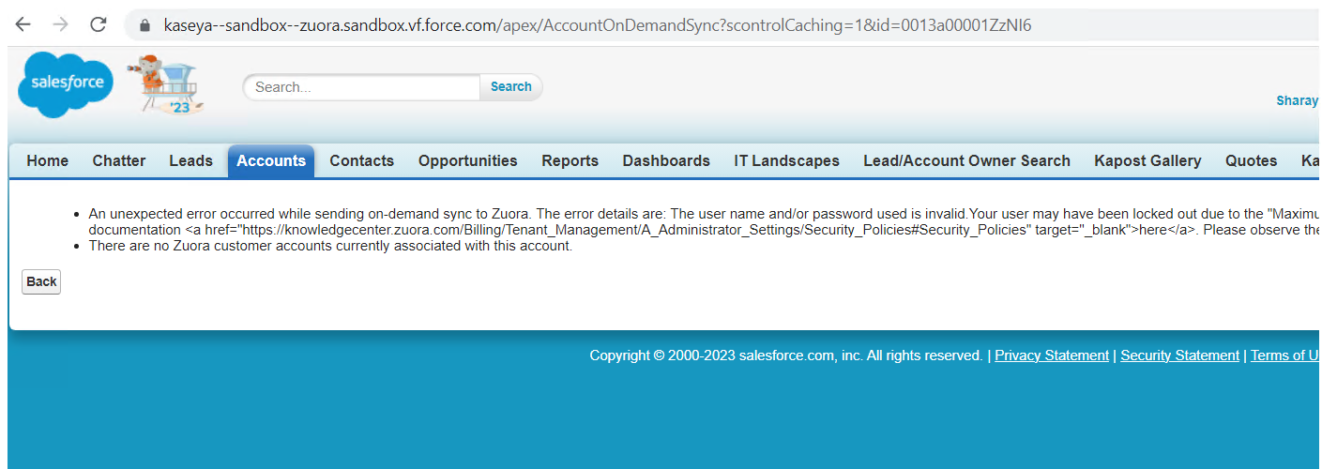

3.) This error appears if the quote link is opened from another user session

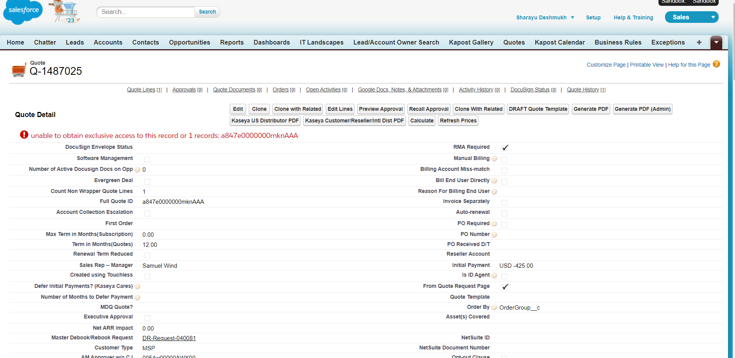

4.) Bill to Contact fields mostly gives error with the contact taken from contract link. If it works fine with Managers contact, can we directly taken manager contact and continue with it?

5.) Product name from the portal's subscription list should always match with the subscription plan mentioned in excel. (If subscription not available in portal what are the next steps?) --skip the trans